**Overview**

India, being one of the biggest countries in the world with a fabulous population has a very strong judiciary system which is inherent with the structure of the courts and its hierarchy and the judicial system. This system provides livelihood to huge number of professionals attached with the system of judiciary in different forms and thus serve the nation with the service.

 The Courts of India guarantees protection of life and personal liberty to one and all. It provides adequate safeguards to fundamental rights against any arbitrary decisions.

The situation has led to suggestions in two Supreme Court reports to increase the judicial manpower, at least seven times, to overcome the crisis by appointing about 15,000 more judges in the coming few years.

“Additional judicial manpower and support staff, as well as infrastructure is required immediately to handle the situation,”

Source of law for Indian Judicial system can be broadly classified in two categories. The first being the statues and legislations passed by the parliament & statues Legislatures. The rules, Regulations and bye-laws issued by Executives is also included in this category only. The second category being the judicial precedents laid down by the supreme court and high court in India, which is binding upon all the subordinates’ courts and tribunals within the territory of India.

**Procedure for court**

* Preparing PLAINT (in duplicate) along with Verifying affidavit, valuation slip, vakalatnama, list of documents, Interim Application(IA), process, copies for the other side.
* Filling of PLAINT before CMO- paying court fees & process
* After numbering, the file will come before court.
* Hearing on IA no.1 (if any IA filed)
* If IA is allowed, compliance is sending IA copy to the other side by Reg. post and filling affidavit to that effect in the court.
* On every interim application there will be stages as follows IA by either of the party – objection by other side – hearing – order on IA
* Or the court will issue notice/summons to other side.

**Return of notice**

* If other side appears they will file vakalat or they will be placed ex-parte.
* If notice is not served to other side Steps to reissue the summons to be taken by filing process.
* If other side appears it will be posted for written statement of defendants.
* After willing of W.S the court will frame issues.
* After issues, evidence of plaintiff (PW) by way of filing affidavit and exhibiting the documents.
* Cross examinations of defendant.
* Argument by plaintiff.
* Argument by defendant.

**QUOTES**

"No man is above the law and no man is below it; nor do we ask any man's permission when we ask him to obey it. Obedience to the law is demanded as a right, not asked as a favour." ~ Theodore Roosevelt

**ABOUT JUDICIARY OF INDIA**

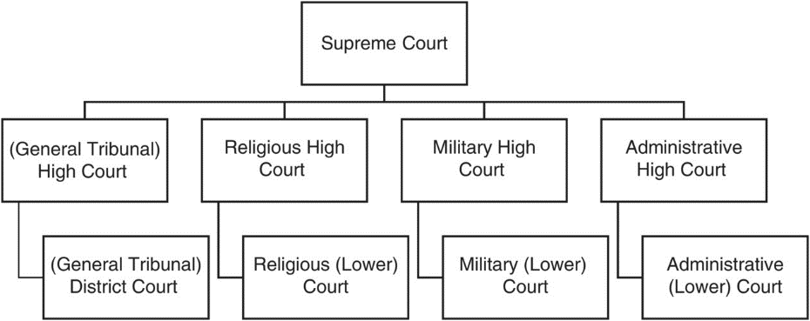

The Ministry of Law and Justice in the Government of India is a cabinet ministry which deals with the management of the legal affairs, legislative activities and administration of justice in India through its three departments namely the Legislative Department and the Department of Legal Affairs and Department of Justice respectively. The Department of Legal Affairs is concerned with advising the various Ministries of the Central Government while the Legislative Department is concerned with drafting of principal legislation for the Central Government. The ministry is headed by a cabinet rank minister appointed by the President of India on the recommendation of the Prime Minister of India.

**Supreme Court of India**

The Supreme Court is the highest court of the country or nation, which is established by the Constitution. Primarily, it is an appellate court which takes up appeals against judgments of the High Courts of the states and territories. However, it also takes writ petitions in cases of serious human rights violations or any petition filed under Article 32 which is the right to constitutional remedies or if a case involves a serious issue that needs immediate resolution.

**HIGH COURTS**

The High Courts are the principal civil courts of original jurisdiction in the state along with District Courts which are subordinate to the High courts. However, High courts exercise their original civil and criminal jurisdiction only if the courts subordinate to the high court in the state are not competent.

**Ranking**

There are various levels of judiciary in India – different types of courts, each with varying powers depending on the tier and jurisdiction bestowed upon them. They form a strict hierarchy of importance, in line with the order of the courts in which they sit, with the Supreme Court of India at the top, followed by High Courts of respective states with district judges sitting in District Courts and Magistrates of Second Class and Civil Judge (Junior Division) at the bottom.

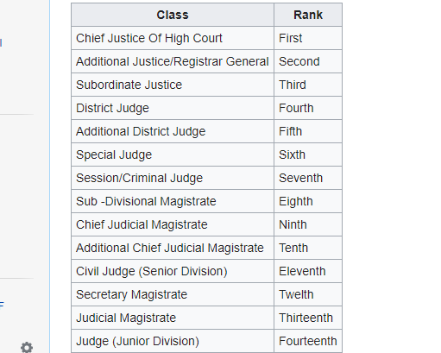

**HIGH COURTS**

|  |  |  |  |  |
| --- | --- | --- | --- | --- |
| **S.No** | **State/UT** | **Principle seat** | **Judges** | **Official Website** |
| 1 | Allahabad High Court | Allahabad | 109 | http://www.allahabadhighcourt.in/ |
| 2 | Bombay High Court | Mumbai | 73 | http://bombayhighcourt.nic.in/ |
| 3 | Calcutta High Court | Kolkata | 33 | http://calcuttahighcourt.nic.in/ |
| 4 | Chhattisgarh High Court | Bilaspur | 12 | http://highcourt.cg.gov.in/ |
| 5 | Delhi High Court | New Delhi | 37 | http://delhihighcourt.nic.in/ |
| 6 | Guwahati High Court | Guwahati | 18 | http://ghconline.nic.in/ |
| 7 | Gujarat High Court | Ahmedabad | 31 | http://gujarathighcourt.nic.in/ |
| 8 | Hyderabad High Court | Hyderabad | 31 | http://hc.tap.nic.in/ |
| 9 | Himachal Pradesh High Court | Shimla | 08 | http://www.hphighcourt.nic.in/ |
| 10 | Jammu and Kashmir High Court | Srinagar | 11 | http://jkhighcourt.nic.in/ |
| 11 | Jharkhand High Court | Ranchi | 14 | http://www.jharkhandhighcourt.nic.in/ |
| 12 | Karnataka High Court | Bengaluru | 25 | http://hck.gov.in/ |
| 13 | Kerala High Court | Kochi | 37 | http://highcourtofkerala.nic.in/ |
| 14 | Madhya Pradesh High Court | Jabalpur | 34 | http://www.mphc.in/ |
| 15 | Madras High Court | Chennai | 60 | http://www.hcmadras.tn.nic.in/ |
| 16 | Manipur High Court | Imphal | 02 | http://hcmimphal.nic.in/ |
| 17 | Meghalaya High Court | Shillong | 02 | http://meghalayahighcourt.nic.in/ |
| 18 | Odisha High Court | Cuttack | 17 | http://www.orissahighcourt.nic.in/ |
| 19 | Patna High Court | Patna | 33 | http://patnahighcourt.gov.in/ |
| 20 | Punjab and Haryana High Court | Chandigarh | 50 | http://highcourtchd.gov.in/ |
| 21 | Rajasthan High Court | Jodhpur | 35 | http://hcraj.nic.in/ |
| 22 | Sikkim High Court | Gangtok | 03 | http://www.highcourtofsikkim.nic.in/ |
| 23 | Tripura High Court | Agartala | 02 | http://thc.nic.in/ |
| 24 | Uttarakhand High Court | Nainital | 10 | http://highcourtofuttarakhand.gov.in/ |

**Instructions for e-filing registration**

* First time users of E-filing have to register through the “Sign Up” option
* Through e-filing only Advocate-On-Record and petitioner-in-person can file cases in the Court.
* Advocate option is to be chosen if you are an Advocate-On-Record otherwise choose in-person option if you are petitioner-in-person
* For Advocate-On-Record, his/her code (Advocate-On-Record Code) would be “Login Id”, while in-person will create his/her “Login Id” through “Sign Up” option. Password needs to be entered the reafter.” Login Id” and “Password” will be created once the mandatory requirements are filled properly.
* After successful login “Disclaimer Screen” appears on the screen. Clicking “I agree” button on the disclaimer allows the user to proceed further.
* After successful login the user can file a case electronically.
* “New Case” option allows the user to file a new case
* Court fee can be paid only through court.
* Defects associated with the e-filed case will be e-mailed to the advocate/petitioner by the Court Registry.

NOTE: Petition filed through e-mail are not accepted. For electronic filing of cases in Court use e-filing facility only.

**Procedures for Petition of case offline**

* Hire a lawyer. Convey your facts to him. He will prepare the petition which will contain all the required affidavits, annexures (If any) and Notice of Motion to the other party.
* This will be filed at the filing counter in the Court.
* The matter will be listed for a future date.
* Your lawyer and you appear on the scheduled date and plead your case.
* Here the court will either admit the petition or dismiss it.
* Where it admits it, it will send the notice of appearance to the opposite party (based on the Notice of Motion filed by you).
* Another date will be fixed for hearing in the presence of such other party (if it chooses to appear).

Things to Note:

* Where the petition is rejected on the first hearing, it is the end of the whole endeavour.
* The fact that the petition is admitted in no way implies that your petition is considered worthy of relief prayed by you. Instead, it only means that the HC considers the matter worth hearing. The petition can still be dismissed at any time.

**Advantages of E-filing**

* Convenience- Filing will be open for 24*7 basis. This accords one the flexibility to work at one’s convenience.
* Space-Where 2 lakh square feet of space is required to keep court files, whereas only 6 square feet of space will be enough after e-filing.
* Immediate Access – An e-filing system which is properly designed to provide online access to files will permit attorneys representing parties to have immediate access to the filings as soon as they are up on site. No more waiting for two or three days for a copy of the brief to come in mail.
* Electronic Text-There are significant advantages to electronic text over briefs and filings on paper. Electronic text can be searched. It can be quickly copied and pasted. It can be stored and archived on computer media, thus saving shelf space. Advocates or litigants can bring their petitions in a soft copying a PDF format at the e-filing centre set up at the court.
* Transparency- It will improve transparency. Any technology which results in quicker and easier access to the courts, under a well-crafted set of rules would ultimately benefit the public.